RCMS User Manual

1. Installation
   1. Download XAMPP 7.3.220 🡪 https://www.apachefriends.org/xampp-files/8.0.0/xampp-windows-x64-8.0.0-2-VS16-installer.exe
   2. Run the installer
   3. Run the XAMPP

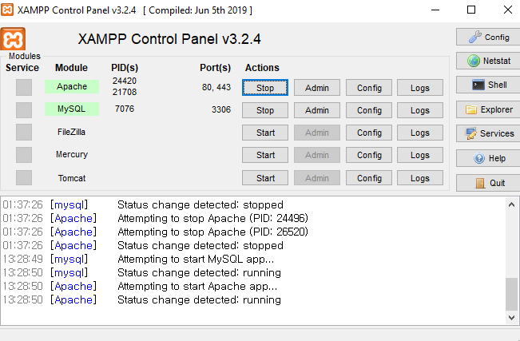

* 1. Export the database. Go to browser and enter “http://localhost/phpmyadmin” 🡪 Import 🡪 File to Import 🡪 Choose file “rcms_new_final_template.sql”
  2. Compile the program / double click the program

1. Application components
   1. GUI

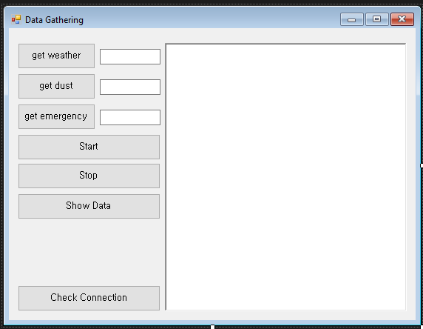

i.

ii.

iii.

vii.

vi.

iv.

v.

* + 1. Single button to download weather, dust, and emergency message at current time. Worked only once
    2. User time input [CANNOT NULL]; for weather and dust indicates the number of minutes when the data will be fetched, separated by comma. Example, fetch data on … 15.50, 16.10, 16.30, 16.50, 17.10, … 🡪 “10,30,50” without apostrophes; for emergency data the number indicates when the data will be fetched every x second. Example set the data to fetch emergency data every 10 seconds 🡪 “10” without apostrophe.
    3. Output of the program but not as detail as console
    4. Button to start the program simultaneously
    5. Button to stop the program from keep running
    6. Button to show the data
    7. Button to check whether the database is connected or not
  1. Console

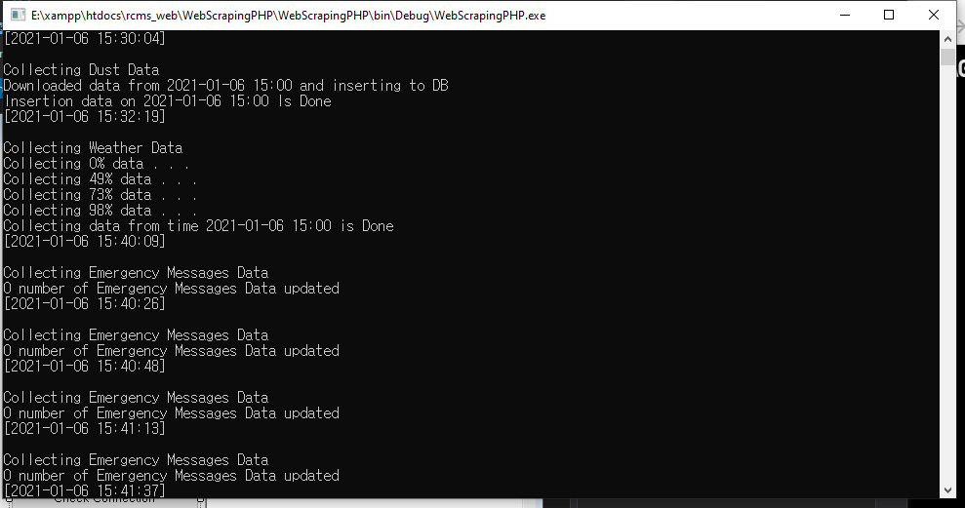

iii.

ii.

i.

* + 1. Sample output of collecting Dust Data
    2. Sample output of collecting weather data
    3. Sample output of collecting emergency data
  1. Database view

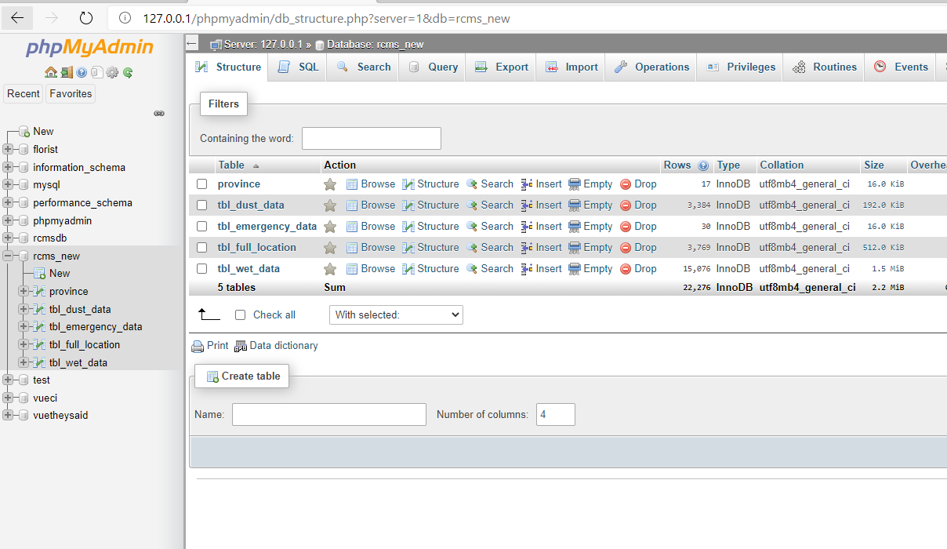

iii.

ii.

i.

* + 1. Selected DB
    2. List of tables
    3. Emergency SQL compiler regarding current database

1. How to use
   1. Double click the program and fill the field on weather, dust, and emergency with the format of:
      1. Weather and dust 🡪 minutes when the program fetch the data separated by comma. Example: … 15.50, 16.10, 16.30, 16.50, 17.10, … 🡪 “10,30,50” without apostrophes

Suggested time: 10, 30, 50 or 5,25,45

* + 1. Emergency 🡪 seconds gap between the program will fetch the data. Example set the data to fetch emergency data every 10 seconds 🡪 “10” without apostrophe

Suggested time: 10

* 1. Click Show Data to show the data
  2. Click Start to start the program. Currently this program runs synchronously, after the program starts, we have to wait until there is some spare times.